**Lose It**:

It is application works online and offline, it asks enter your current wait, height, your birthdate, what you want your wait to be and in how speed (slower – faster) then it calculate the calories in a day to eat, then you will enter what you eat breakfast, lunch, dinner, snacks and exercise you can search about everything and count the amount of every one and calculate the total calories if you pas the amount of your day the number of calorie will change to red button, if you play exercise it ask about the time then calculate the calories that you may lost and subtract from the total calories, there is a social you can add friends and send massages to be a success and to motivate each other, it send you notifications to remind you that you don’t enter food or something , and it send welcome message and other on you email.

It talk and appear what happen in all those features throw the diet.

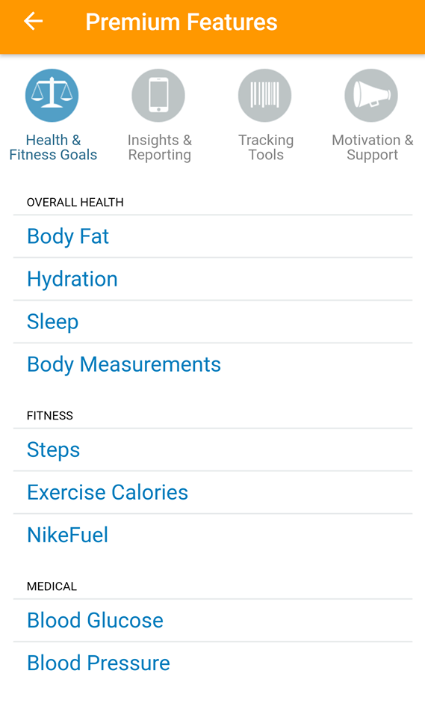 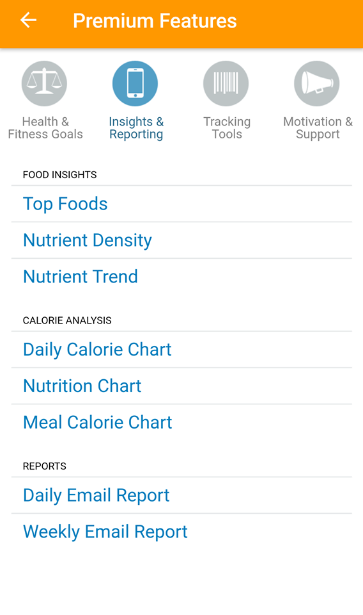

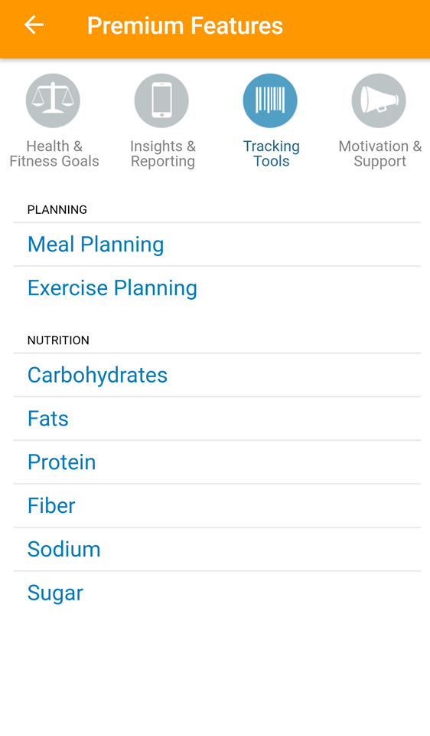 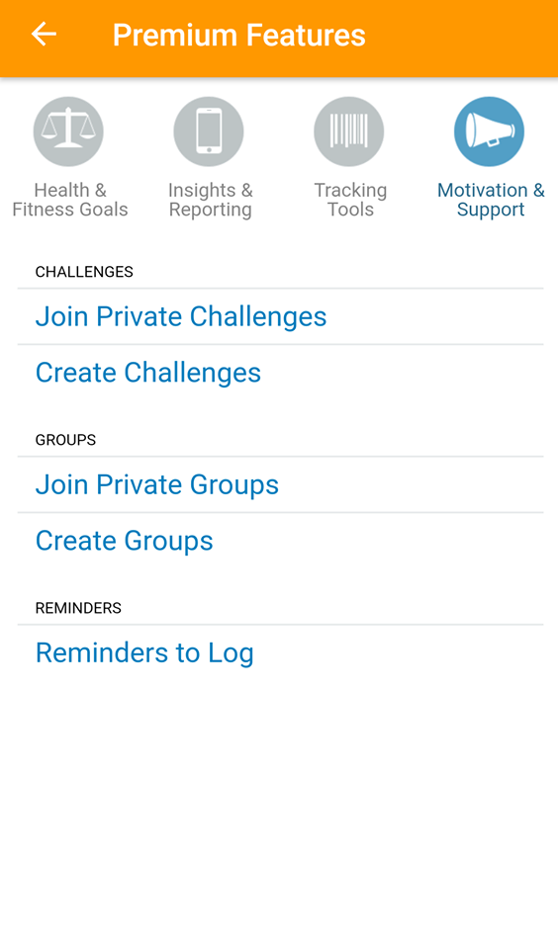

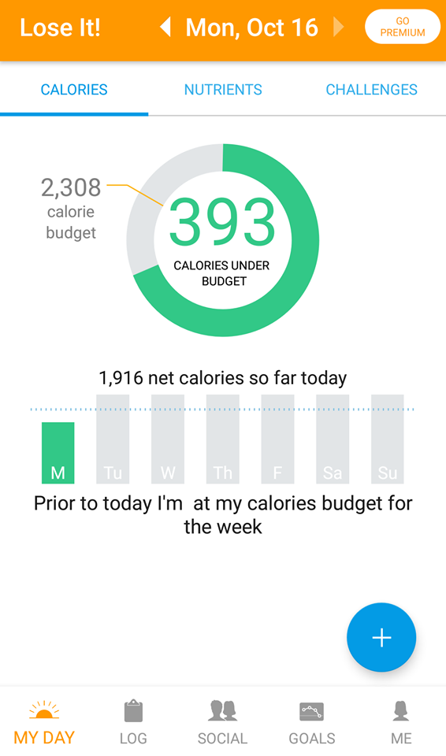 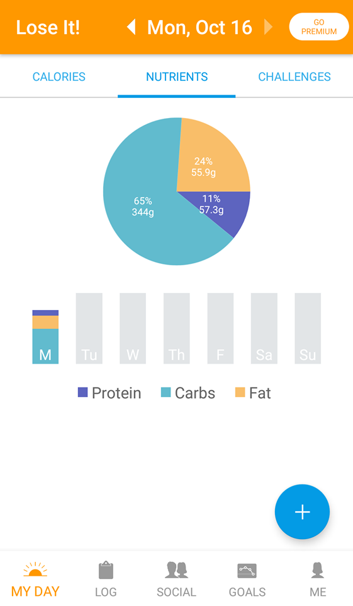

**MyNetDiary App :**

this app allow the user to set his/her main goal of using it by choose what they want from the app (lose, maintain or gain weight) and by choosing the gender ,current weight target weight of the user it will give them the target daily calories exactly the weekly rate kg’s of lose or gain and target date .  
This app allow the user to input all the meals with its calories budget (breakfast, lunch, dinner, snacks) by search for these meals or scan it or add custom food with the specific quantity for this item , After you complete all these steps it will also give the user the quantity of fats, carbs and proteins .

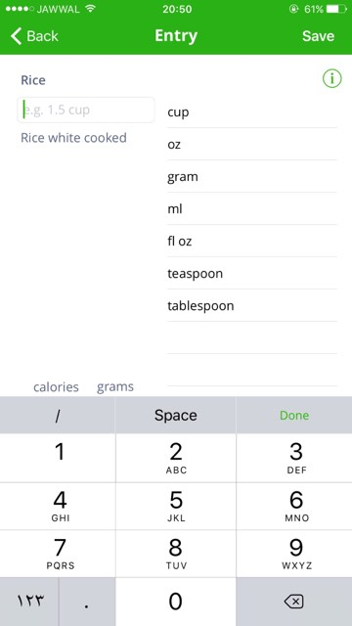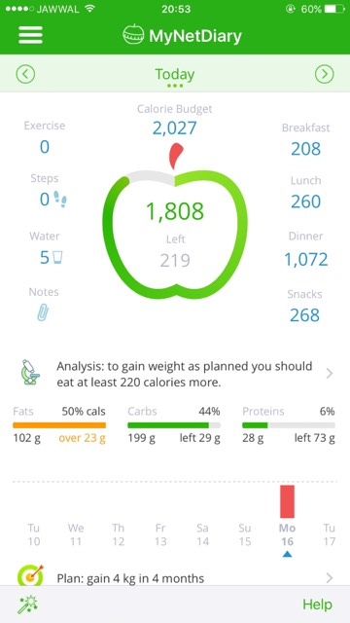

-this app has a friendly UI and easy to use

-allow the user to connect with friends and family.

-allow the user make healthy food choices and get more active.

**Fat secret app:**

Fat secret is a health app that can be specify as a nutrition app , and this app have a good ideas and feature can help us in our project ,generally the main purpose of it to calculate calories by track you daily meals.

To specify how it work :

Firstly before sign up you have to answer question that arranged sequentially And to go from question to another you can move forward and backward so if u need to change any entered information its seem for us easy ,therefore , the way it move we find the questions relate to the aim of app and they were clear , and those question were my goal ,weight, gender, activity level and every think were specified about this question ,height and my birthday, then we sign up so from these steps we find that app have a friendly user interface and have a simplicity feature , so I wish we could start in a same way with interface encourage user to answer the hole questions without filing back using our app, our app will make u answer the same questions without answer the goal question in our app after sign up you will find advice help u to chose your goal .

After sign up in the bottom of screen you will find home which is a place to share people your status so I think its a good feature , you will find beside first choice a diary choice which is the place u enter your daily meal and it supported with ready choice u can choice it by search feature in the top of screen then you will find the report which contains your daily report , finally you will find weight choice which contain weight changes in every month or every time you change it